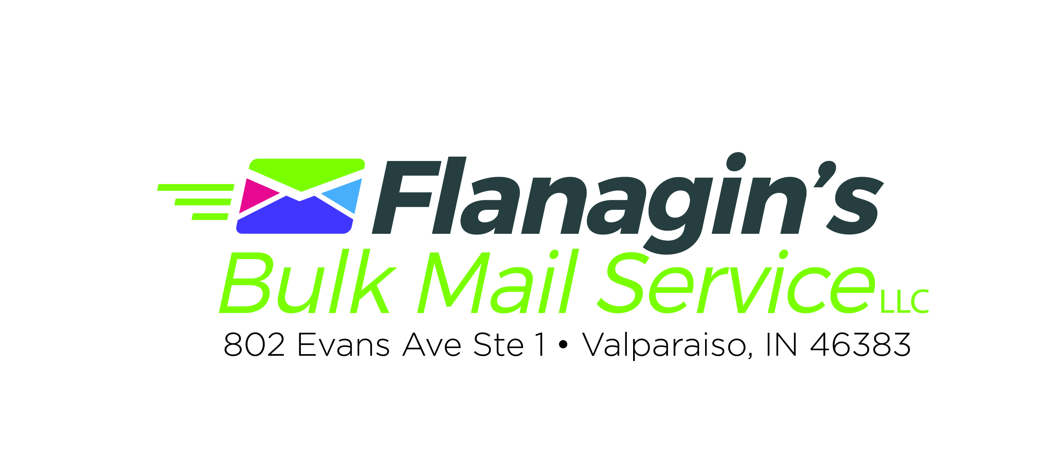

Frequently Asked Questions

Do I need my own postage permit?
No. If you use our service you can use our permit for FREE, and you will be able to save the application fee and annual fee at the post office.

What exactly does your mailing service do?
We are an automated mailing service which means we are going to get you the best postage rates the post office offers based on your mail piece and list. To accomplish this, we need your data sent to us electronically. We will process your data through our software program which will standardize your addresses, sort it to the best level for the post office and then address your mail piece with barcodes and appropriate paperwork. This is the reason the post office gives us better rates than you can acquire on your own.

Mail Myth: If I print labels and label myself I will be saving money.
It is actually the opposite. When we address the piece we are bar-coding and sorting to the USPS standards and for that work they give us better postage rates. When you produce labels, we are not doing that work for the post office so we do not get those good rates. Add on your time and the cost of the labels, it has cost you more than necessary.

Why can’t I do bulk mailing myself?
You could, but why would you? The main reason you don’t want to mail it yourself is because we are going to get you better postage rates. It’s that simple. Factor in the cost of your time and delay in getting your mail prepared and you have already saved our fee. Also you can save the application fee and annual fee by using our permit.

Can I mail the extras using your permit?
No, unfortunately even though the permit says “US POSTAGE PAID” it actually isn’t paid until the mail gets to the post office. You can, however, place a first class stamp over the permit and mail them that way.

From what post office will my mailing be mailed?
Your mailing will be mailed from the post office where the permit originated. In our case, that will be the Valparaiso post office. If you have your own permit from a different post office, the mailing must be presented there, but we do encourage you to use our permit for expediency.

Do you use labels or inkjet?
We actually offer both services. The preferred method is inkjet, but sometimes the piece design requires us to use labels. Each job is decided on an individual basis. Please note there is an additional charge if we print and apply labels.

How long will it take my mail to be delivered?
If you mail First Class Presort, your mail will typically be delivered at about the same speed as a First Class stamp. If you select Standard Rate, it will typically be 3-10 days, depending on how far away your mailing is going. If it is going across the country it can even be longer than 10 days. Please remember that in both cases, we have no control over how fast or slow the USPS delivers your mail.

If I stuff my own envelopes and want you to seal, should the flaps be open or closed?
Please leave the flaps down. Our sealing machines need the envelope flap to be down, just like it comes in the original envelope box. Also, be careful to keep them all going in the same direction. We will be putting them in a machine, so they all need to be uniform. Also remember NO metal clasps on any envelopes.

Do I need to tab my mail piece?
We do have wafer tabbing services, so you do not need to do this step by hand. We can do it very quickly with our machine. If you would prefer to do the tabbing yourself, we just request that you get the tabs from us. Many of the tabs purchased at the local office supply store do not stick very well and that will cause problems for us in the printing process.

Do I need a certain amount of pieces to any one zip code?
No, you are only bound by the minimum requirements at the post office.
The minimum for standard mail is 200 pieces and first class mail is 500.

What format do I need my data in?
We can work with many different formats, but the most common are Excel, Access, and comma delimited. If you are in doubt, give us a call.

Can I mail to anywhere in the United States at a discounted rate?
Yes, as long as you meet the minimum requirements of 200 for standard mail and 500 for first class presort.

What is the difference between targeted mailing and saturation mailing?
Targeted mailing is when you are trying to mail to specific people or specific criteria of people. Saturation mailing is when you are mailing to the address and not necessarily the specific person, like Current Resident or Occupant. You are actually saturating an area, mailing to every deliverable address.

What is a saturation mailing?
If you would like to hit absolutely every household in a particular area, this is what you want. We can break it down by zip code or carrier route and we can help you target subdivisions. We can also do a radius around your business or home.

I do not have a list - what do I do next?
We can assist you in purchasing a mailing list. You can create your own list from your current clients or phone book, or you can ask us to do this for you. If saturation mailing is what you need, then you do not have to create that list, as we will do that for you.

Do you print the mail pieces?
No, we are not a commercial printer. We are a mail house. We do all the steps that it takes to get your piece mailed, after it is printed. If you don’t have a printer, we can connect you with one.

What is aqueous or UV coating?
To simplify this, it is a varnish type coating which speeds up the printer’s drying time and, in some cases, gives it a high gloss finish. We DO NOT recommend using coatings on the mailing side of your piece because our ink will not absorb. In some cases we have to apply labels instead of inkjet if it is coated. Request that the coating be left off on the mail side when you talk to your printer. Remember if we have to label, it will cost you more.

I am a non-profit company. Do I need my own permit?
You do not need to invest in a permit, but you do need to get an authorization number from the USPS, and then we can use our permit on your behalf. We can help you with that process. Caution: Non-profit with the IRS does not necessarily constitute non-profit with the post office.

What is NCOA (National Change of Address)?
When a person or business moves and fills out a change of address form with the US Postal Service, this information is added to a giant database and kept for 4 years. It takes between 4-6 weeks for new changes to reach this database.

How do I pay for the postage?
After we process your file, we can tell you what your exact postage will be. The postage will be due before the mailing goes out. You can pay by check or cash, or if you prefer you can deposit the funds in our permit account at the post office. If you choose to pay by credit card there will be a service charge added.

What does the post office consider a postcard?
As long as your card it not larger than 6.0” wide x 4.25” tall it can go at postcard rate as long as you meet the 500 piece minimum requirement. If your postcard is larger than this, it will go at standard rates.

What is the different between postcard, standard and flat sizes?
The three mailing categories are determined by size, weight and thickness. Refer to the page titled dimensions.

What is an aspect ratio?
The aspect ratio applies to postcards and standard size mail pieces.
The length divided by height must be more than 1.3 or less than 2.5. If you do not meet the aspect ratio, your mail piece will not qualify for the best postage rates.

What is the minimum number of pieces I need to get postage discounts?
Basically it is 200 pieces for standard mail and 500 pieces for first class presorted mail.

Can I give you pre-printed address labels?
Yes, but your overall mailing will cost you more. We cannot get the same discounts on pre-printed labels as we can get when we address your piece. If you choose to print your labels, use zip code order NOT alphabetical order. If you choose to label yourself remember to place the label on straight and as close as possible to the same place on all mail pieces. Also, keep all mail going on the same direction when in the box or tray. We will be taking handfuls and putting them on our machine, so they need to be all the same direction. Also we will have to add “or current resident” or “return service requested” to your mail piece go qualify for move update verification.

Why is tabbing sometimes required?
Tabbing is required for automation postage rates for a folded self-mailer if the self-mailer “pops open” if left by itself. The tabbing assures the post office that your mail piece can be processed on their machinery.

Why do you want the fold on the bottom and tab on the top for a folded mail piece?
This is a US Postal Service requirement. This will save you money and your mail piece has less chance of getting jammed in the post office equipment.

Do all my mail pieces have to be identical?
Yes, a bulk mailing must be identical. That includes color, weight and shape.

Do you do EDDM mailings (Every Door Direct Mail)?
Yes we do. With EDDM mailings remember that the mailing MUST be shipped/driven to the destination post office and the size must be a flat size. (refer to page titled dimensions). We also do saturation mailings which are very similar but do not have the same requirements. For more information call us or visit https://www.usps.com/business/pdf/quick-reference-guide.pdf

Can I mail raffle tickets? PS-307 (601.12.3 USPS DMM)
Raffles that incorporate “prize”, “chance”, or “consideration” are considered lotteries under the statute and postal standards. “Tickets” for such raffles are considered unlawful mail matter and remain not mailable.

When one or more of the three elements (i.e. price, chance, consideration,) are eliminated from the raffle, the arrangement does not constitute a lottery for postal purposes. For instance, “consideration” is eliminated if persons may enter without payment of a fee. Thus, a non-profit organization that designs a raffle where it is clear that a donation is not required (e.g. via a check box, “Please enter my name in the drawing. I do not with to make a donation at this time”) to participate in the raffle may use the mail to distribute the tickets for that raffle.

802 Evans Ave Ste 1
Valparaiso, IN 46383
219-464-9871 Phone
219-464-9787 Fax
dflana22@comcast.net
www.mybulkmail.com

