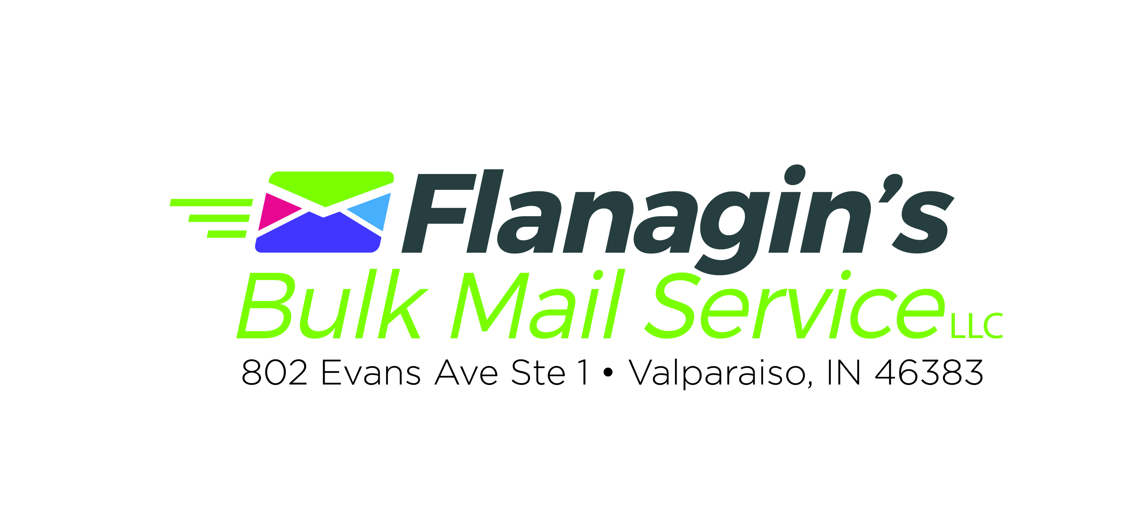 | Rev 3-17-18  802 Evans Ave Ste 1  Valparaiso, IN 46383  219-464-9871 Phone  219-464-9787 Fax  dflana22@comcast.net  www.mybulkmail.com

MONEY SAVING CHECKLIST

BEFORE YOU PRINT………..

- 1. EMAIL OR FAX PROOF to Flanagin's before you print.

- 2. ORDER ENOUGH PIECES to cover the full mailing plus 5-10 extra.

- 3. CHOOSE PERMIT (see reverse side) Have permit pre-printed on your piece where a stamp would normally go. If you are uncertain which permit call or email.
Critical
- 4. FOLD ON BOTTOM AND TAB ON TOP. (If the opening is at the bottom it cannot be mailed)

- 5. ADDRESS BLOCK & BARCODE SPACE. An easy safeguard is to leave the lower right hand corner completely blank. 3 ¾” x 2 1/8”. Email or Fax us your proof before printing so we can approve for postal qualifications.

MINIMUM MEASUREMENTS 2 1/8”

3 ¾”

- 6. ASPECT RATIO. Measure your mail piece. Length divided by height must be more than 1.3 or less than 2.5.

- 7. SELF-MAILER TRI FOLD The address panel should be the middle panel and on min 28# paper.

- 8. NO AQUEOUS / UV / OR VARNISH COATED PAPER. Our ink will not adhere to coated paper, it will just smear. Request the mail side free from coating. It if comes coated, we will have to apply labels at an additional charge.

- 9. FLAPS DOWN if you are bringing already stuffed envelopes that you want us to seal, please keep the flaps down and all envelopes facing the same direction.

- 10. IDENTICAL PIECES A bulk mailing MUST be identical. That means color, weight, and text. Even a poor cut will affect the weight so be sure they are cut professionally.

- 11. PRE_PRINTED LABELS will cost you more in postage (electronic lists recommended). We cannot get you the best postage if you pre-print labels or pre-address your mail.

- 12. DATA Preferred format is excel, dbase or .csv Do not send us your data as a PDF file. Send your data by email attachment.

- 13. GOOD IDEA to add your own name to your mailing list so you will know when the mailing starts to arrive.

- 14. 28# PAPER minimum weight. USPS requirement (20# paper is too thin so be careful when purchasing. Thin paper will not go through the folder, wafer tabber, inserter or USPS equipment properly.
- 15. NON-PROFIT Mail qualifying for Nonprofit Standard Mail prices must have the name and return address of the authorized nonprofit organization either on the outside of the mail piece or in a prominent location on the material being mailed (inside the mail piece) (703.1.5 USPS DMM).
- 16. POSTAGE IS DUE BEFORE THE MAILING GOES OUT. Company check, cash or credit card accepted ( with credit card there will be a service charge of 4% added to the final invoice total).

- 17. MOVE UPDATE REQUIREMENT All discounted mail must have proof of move-update. Move-updates are good for only 95 days.

You need to choose one of the options:
1) Have us add “Or Current Resident” to your piece (no charge)
2) Have us add “Return Service Requested” to your piece (you will pay first class return postage for any that are returned)
3) Have us add “Change Service Requested (you will pay address correction fee for each separate notice)
4) Have us send your list through National Change of Address at 2 ¢ per submitted record. You will receive a report of all moves located to update your master database. Preferred option for overall savings. Reduce postage, printing, & labor on all future mailings.

- 18. ENVELOPES Prefer machine insertable envelopes for all styles. Invitation style envelopes with square flaps
have to be hand sealed so there is an additional surcharge for square flaps. Good alternative for square flap envelope would be Western States Sulphite 7056 A- 6 4 ¾ x 6 ½ or comparable.

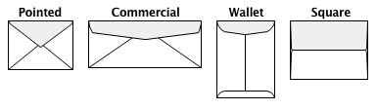
<<Square flap undesirable

Not machinable Preferred Acceptable Undesirable (addn’l surcharge to hand seal)
Not preferred

- 19. EDDM ADDRESS AREA. If you are doing EDDM mailing. The following should be pre-printed on your mail piece. Call for EDDM requirements and step by step instructions to the USPS maps. Postal customer = business & residential - Residential customer = residential only no businesses.

Prsrt Std
US Postage
PAID
Valparaiso, IN
Permit # 134

***ECRWSSEDDM
Local
Postal Customer OR Residential Customer

_______________________________________________________________________
- 20. FLAT SIZE MAIL Acceptable labeling areas for flat size mailings.

FLAT SIZE MAIL LABELING

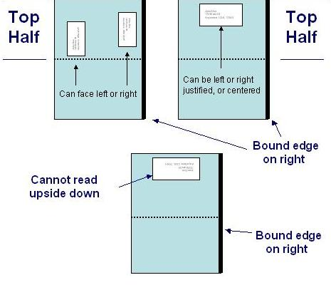
____________________________________________________________________________
Indicia Formats
(indicia placement is where a stamp would go)

(Bulk Permit) (First Class) (Non-Profit) Acceptable Business
(200 pc min) (500 pc minimum) (200 pc minimum) Permit Format
Prsrt Std
U.S. Postage
Paid
Valparaiso IN
Permit No 134

First Class Prsrt
U.S. Postage
Paid
Valparaiso IN
Permit No 134
Non-Profit Org
U.S. Postage

Paid
Valparaiso IN
Permit No 134
Prsrt Std
U.S. Postage
Paid
Flanagin’s Bulk Mail Service LLC

